The Psychological Breach: Social Engineering in the AI Era

Course: ITC 4610 Penetration Testing
Prepared by: Mandip Amgain
Date: April 8, 2026
Professor: Betty J. Lauer

I. Executive Summary
In the modern cybersecurity landscape, the "Human Firewall" is under unprecedented stress. As organizations adopt Zero-Trust Architectures and robust encryption, threat actors have shifted their focus from exploiting code to exploiting human cognition. This report analyzes the current state of social engineering, the role of Generative AI (GenAI) as a force multiplier, and the strategic shifts required to defend both personal and corporate assets in 2026.
II. Defining the Threat: The Mechanics of Manipulation
Social engineering is the psychological manipulation of people into performing actions or divulging confidential information. Unlike technical exploits, it directly targets the inherent trust and cognitive biases of the human mind, exposing a critical weakness that demands urgent attention.
The Lifecycle of an Attack
- Investigation: The attacker uses Open-Source Intelligence (OSINT) to gather data from LinkedIn, GitHub, and corporate "About Us" pages.
- The Hook: Contact is initiated. The attacker creates a "Pretext” a fabricated scenario (e.g., "I’m the new IT auditor").
- Exploitation: Leveraging urgency or fear, the attacker extracts the payload (credentials, MFA codes, or unauthorized wire transfers).
- Exit: The attacker closes the interaction in a way that minimizes suspicion to delay incident response.
Psychological Triggers (The Security+ "Big Six")
- Authority: Impersonating executives or law enforcement.
- Urgency: Creating a false time limit (e.g., "Account lock in 10 minutes").
- Social Proof: Claiming others have already complied.
- Scarcity: Offering limited rewards.
- Likability: Building rapport through shared interests discovered via social media.
- Fear: Threatening negative consequences for non-compliance.
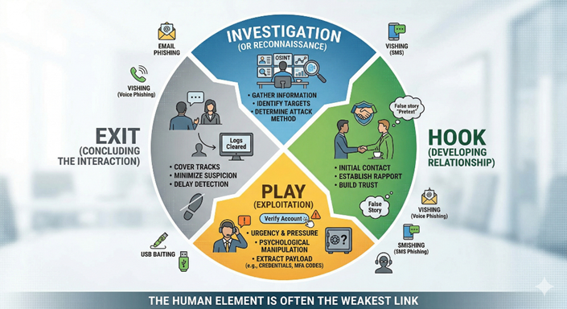
Figure 1: The Four-Phase Attack Model. This diagram illustrates the structured reconnaissance, establishing trust, and exploitation required to bypass technical controls, showing that reconnaissance (Investigation) is often the longest phase.
III. The Evolution: From Phreaking to Deepfakes
Social engineering has evolved through three distinct eras:
Traditional (1970-1990s) | Telephony | Phone Phreaking & Dumpster Diving
Digital (2000-2020) | Email | Mass Phishing & Spear Phishing
Modern (2023-Present) | AI / Synthetic Media | Deepfakes, Vishing, & Hyper-Personalization

IV. Technology's Role Today: The AI Revolution
The year 2025 marked a turning point where AI became the primary tool for social engineers.
1. AI-Powered Phishing
Attackers now use Large Language Models (LLMs) to eliminate the "red flags" of traditional phishing.
- Zero-Grammar Errors: AI produces perfect syntax, making lures indistinguishable from internal corporate comms.
- Mass-Personalization: AI can scrape thousands of social media profiles and write 1,000 unique, highly targeted emails in seconds.
2. Deepfake Vishing & Video
Voice cloning is the most dangerous development in recent years. Using Retrieval-based Voice Conversion (RVC), an attacker can clone a voice from a 30-second clip of a YouTube interview.
- The "CEO Gift Card" Scam 2.0: Instead of a sketchy email, the employee receives a phone call or joins a Teams meeting where the "CEO" (a deepfake) asks for urgent financial assistance.
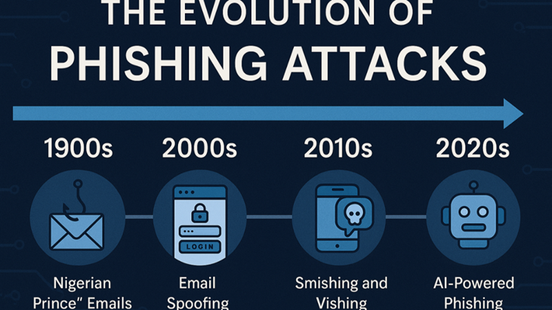
Figure 2: Evolution of phishing techniques over different decades
V. Current Facts & Statistics (2025-2026)
- The Success Rate: Social engineering is the initial access vector in 36% of all global security incidents (Sprinto, 2025).
- AI Integration: Over 82% of phishing emails now contain AI-generated content to bypass traditional spam filters.
- The Financial Toll: The average cost of a breach involving social engineering has risen to $4.9 million, largely due to the time it takes to detect "insider-style" credential theft.
- MFA Vulnerability: Attacks on Multi-Factor Authentication (MFA), such as MFA Fatigue and Session Hijacking, have seen a 45% year-over-year increase.
VI. Case Study: The "Scattered Spider" Impact
The 2023-2024 attacks on major hospitality giants (MGM/Caesars) became a blueprint for 2026. Attackers impersonated employees via the IT help desk to reset MFA devices, bypassing all technical firewalls and proving a 10-minute phone call can outmatch a $10 million firewall.
VII. Defending the Human Perimeter
Private/Individual Defense
- Hardware Security Keys (FIDO2/WebAuthn): Moving away from SMS codes to physical keys (e.g., YubiKey) that are "phishing resistant."
- Digital Footprint Reduction: Pruning PII from public records to limit an attacker's "Investigation" phase.
Corporate/Public Defense
- Zero-Trust for Humans: No request is trusted based on "voice" or "face" alone.
- Out-of-Band (OOB) Verification: Mandatory secondary verification through a different channel (e.g., "I see you on Zoom, but I'm going to Slack you with a code to verify").
- Interactive Training: Replacing passive videos with live-fire phishing simulations and "escape room" style security challenges.
VIII. The Future: 2027 and Beyond
As we look toward 2027, we predict the rise of Autonomous Social Engineering Bots. These bots will engage in long-term "social grooming" on platforms like LinkedIn or Discord, building trust over months before launching a payload. The cybersecurity industry must pivot toward Behavioral Analytics, focusing on "how" a user is acting rather than "who" they claim to be.
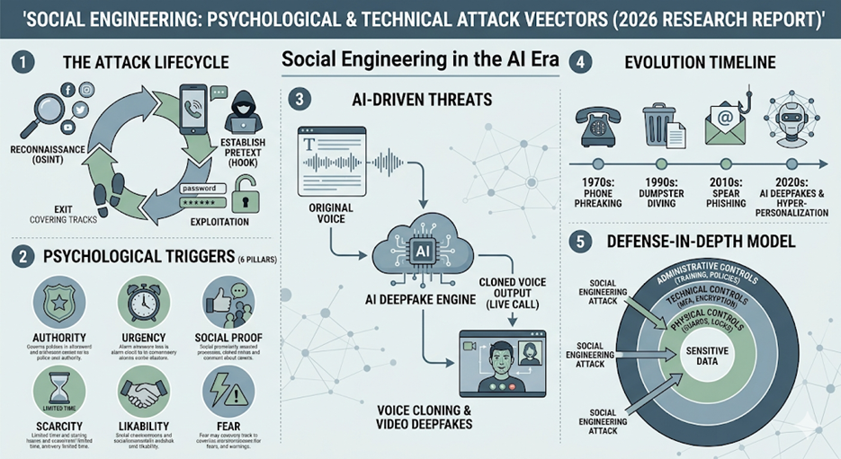
Figure 3: Comprehensive Overview of Social Engineering Attack Vectors and Defenses. This figure illustrates the transition from traditional methods, such as dumpster diving, to modern AI-driven deepfakes, alongside the psychological pillars and the multi-layered defense-in-depth model required for mitigation.
IX. Conclusion
Social engineering is the most "human" problem in technology. While technical controls are necessary, they are insufficient against an adversary that hacks the heart and mind. To survive the AI-driven threat landscape, our defense must be as adaptive as our attackers, relying on a culture of Verified Skepticism and a relentless commitment to security education.

Reference
Sprinto (2025). 100+ Latest Social Engineering Statistics: Costs, Trends, AI. 2. USACyber (2025). Advanced Social Engineering: 6 Evolving Techniques.
CompTIA. SY0-701 Exam Objectives (Domain 2.0: Threats, Vulnerabilities, and Mitigations).
Verizon (2025). Data Breach Investigations Report (DBIR).

